

|  |
| --- |
|  |
| **Spring Cloud Gateway Prototype** |
|  |

|  |  |  |  |
| --- | --- | --- | --- |
| **Change Record** | | | |
| **Document Version** | **Description of Change** | **Change Effective Date** | **Change Entered By** |
| 1.0 | Initial draft | 04/22/2022 | John Cusey |

Table of Contents

2 Introduction 4

3 GitHub Repositories 4

3.1 Code Base 4

3.2 SoupUI 4

3.3 Request and Response JSON Files 5

4 Request And Response 5

5 First Service SoapUI 6

6 Second Service SoapUI 7

7 Gateway Service SoapUI 7

8 Gateway POM File 8

# Introduction

This prototype demonstrates how to call two separate services with a Spring Cloud Gateway. Let's say a student has attended two different colleges Cornell and Fortis. The students can search and all the purchases that they had made at these two colleges.  The Gateway calls Cornell and Fortis colleges API and combines the result of the search into one response API. In this example, I combined the products part of the two JSON responses from Cornell and Fortis colleges. The Cornell and Fortis request and response APIs can be different. Spring Cloud Gateway allows you to alter request and response APIs.  In this example, I took Fortis Request and mapped it to Cornell Request when calling the Cornell API. The difference between the Requests is Department Name.

Note: In the header I set DATA to REQ001.

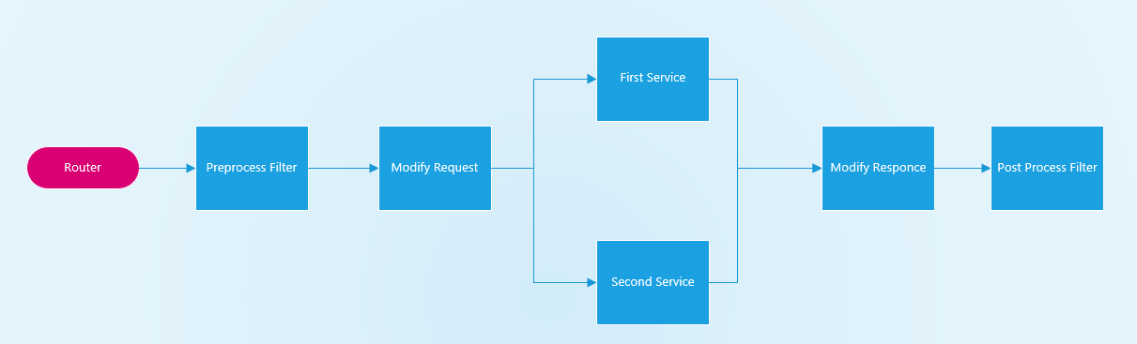

* Preprocess and Post Filter you access the header
* Request and Response Modify is where the JSON Spring is convert into POJO. I do the Mapping POJOs. You access the header in the Modify.

# GitHub Repositories

## Code Base

* first-service
* second-service
* gateway

## SoupUI

* gateway/SoupUI

## Request and Response JSON Files

* first-service/InputFiles
* second-service/InputFiles

# Request And Response

The First and Second Services use Jackson Library to read JSON file and convert it into Plain Old Java Object (POJO). Below you can see the JSON files used. 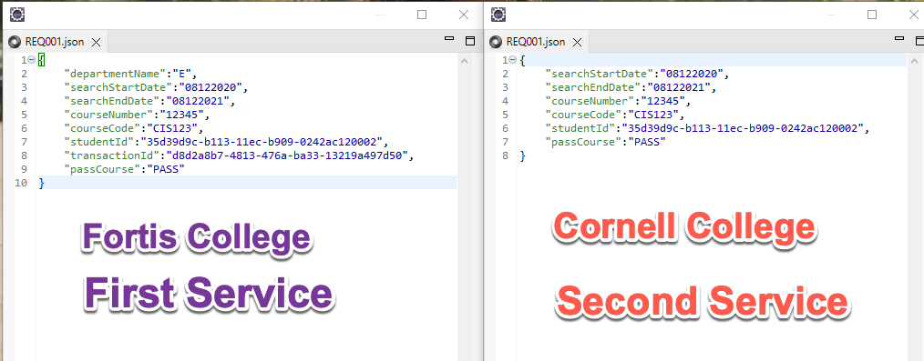

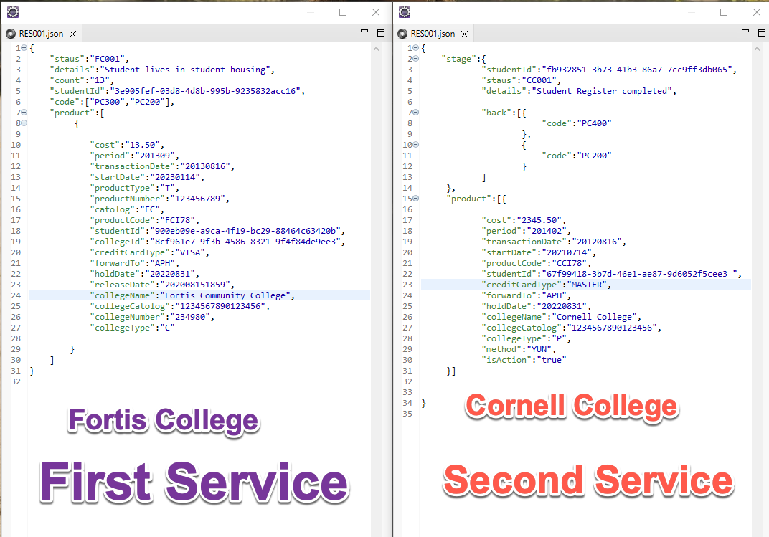

# First Service SoapUI

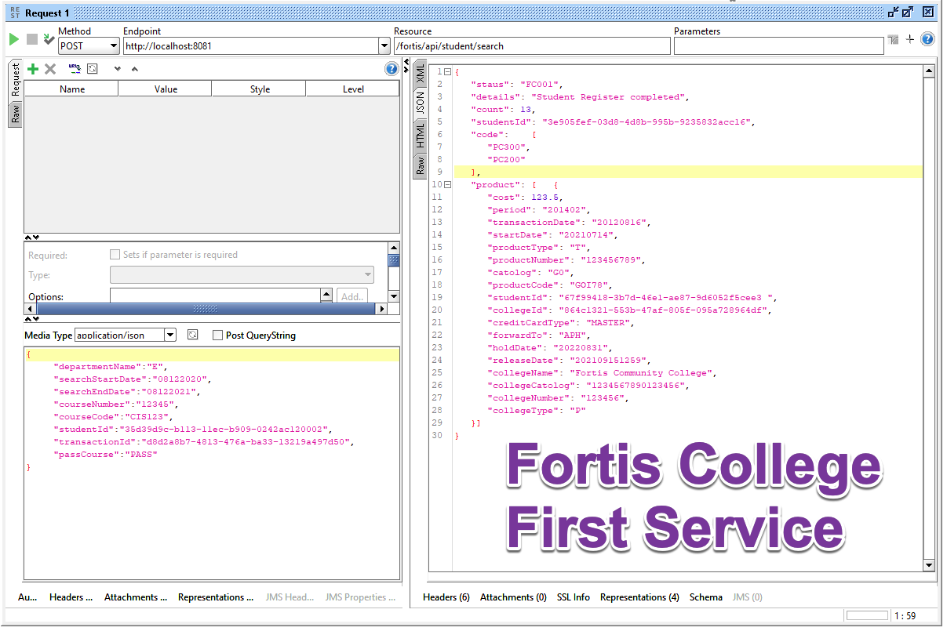

# Second Service SoapUI

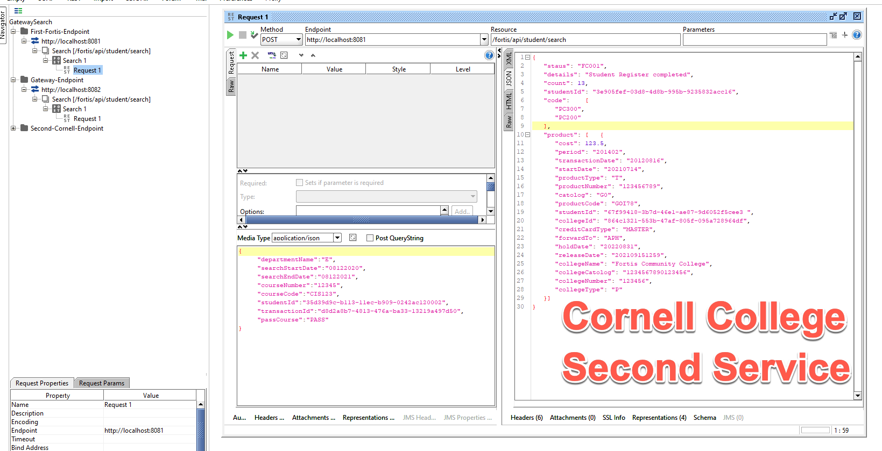

# Gateway Service SoapUI

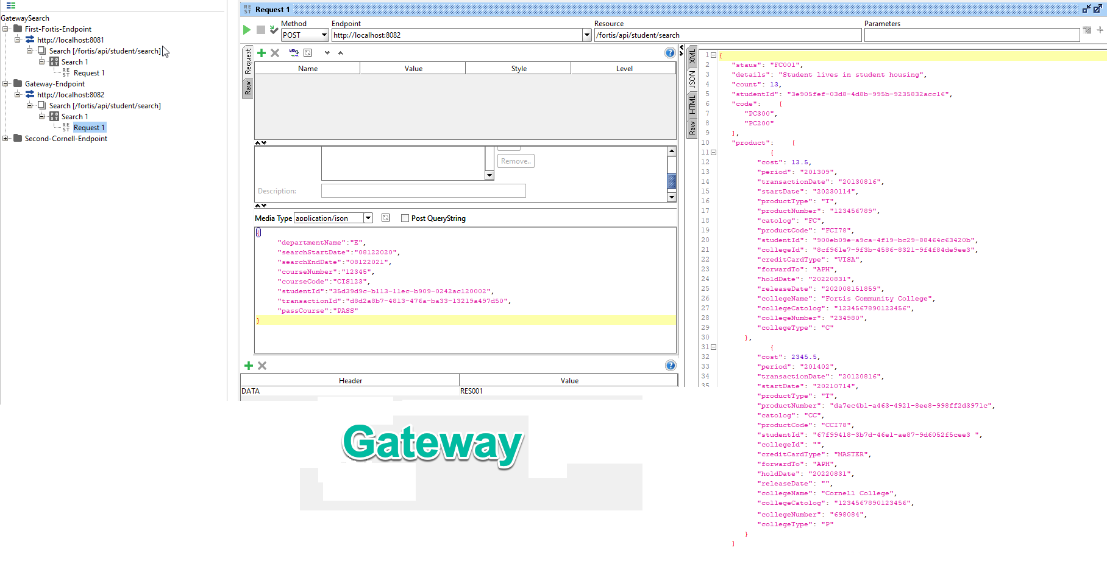

# Gateway POM File

